How to create your own Weebly Site
Go to Weebly.com
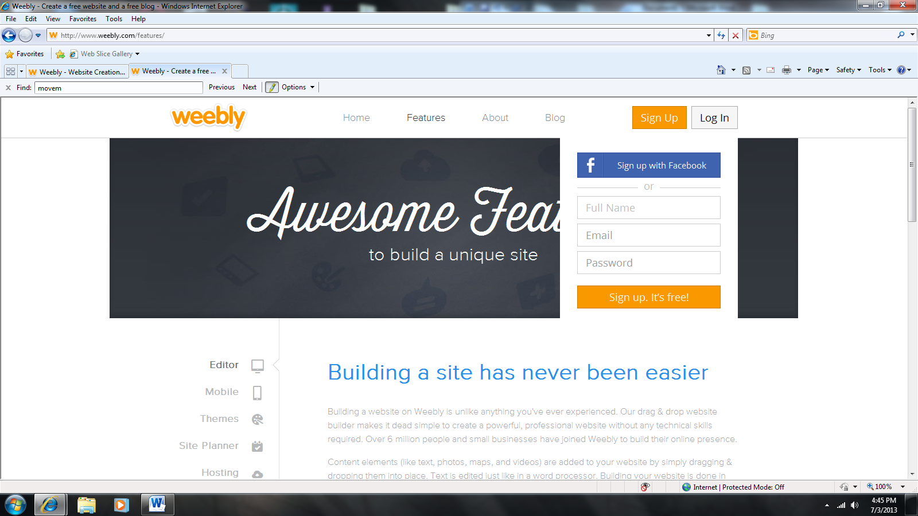
Fill out the information in the top right hand corner.
Select a Theme for your website.
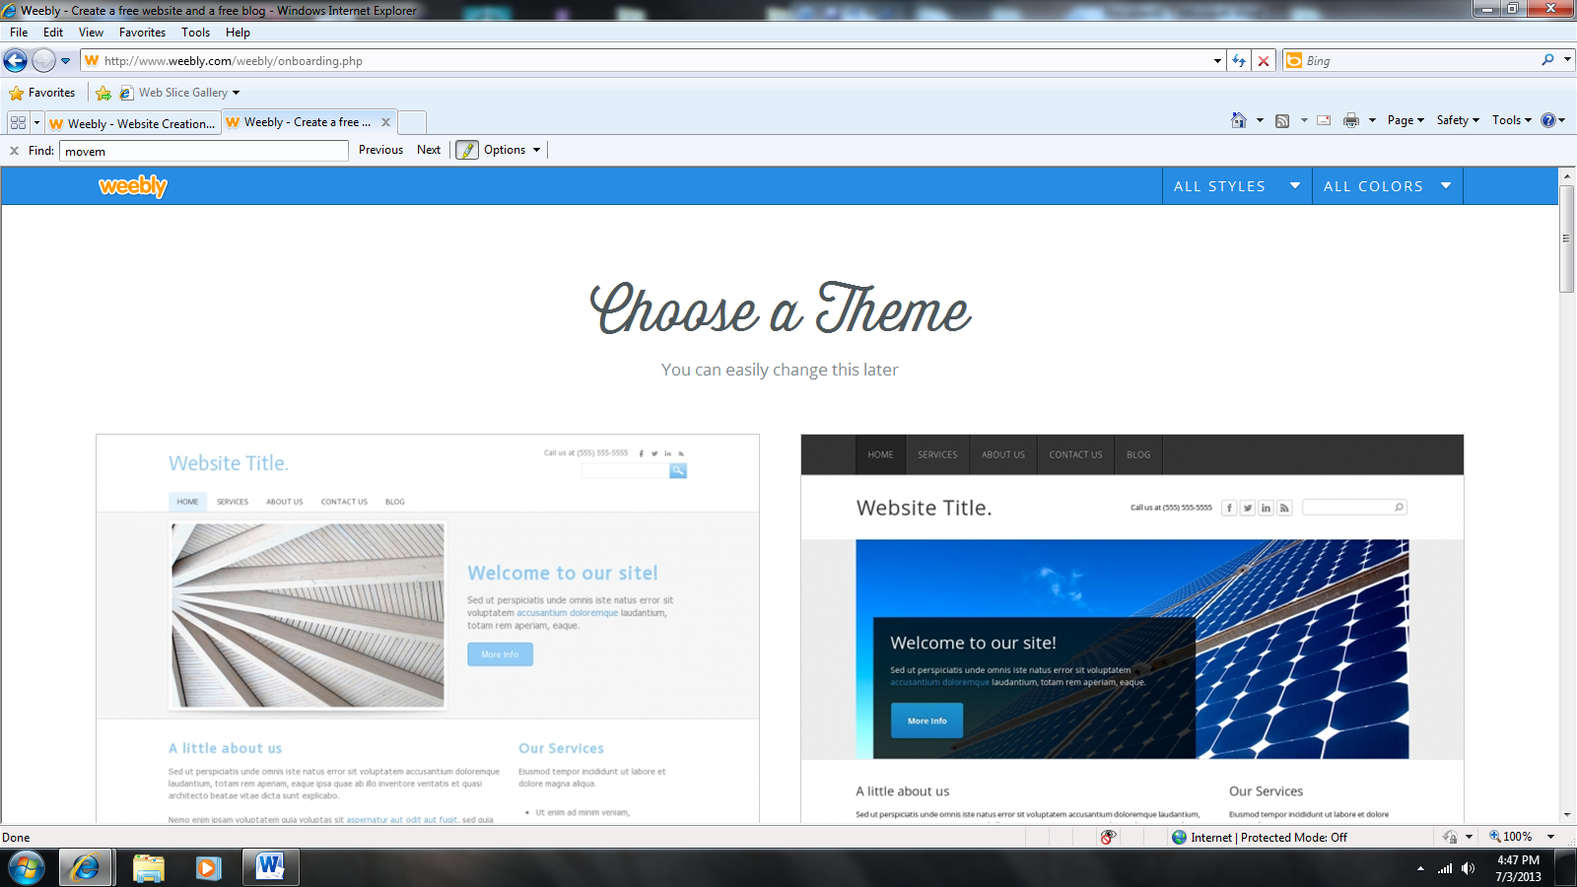
Change colors at the bottom of the website designs to the one you like and hit choose.
Next choose your website name. For this I want you to us the following. Select “Use a Subdomain of Weebly.com” and write your full name with an s followed by portfolio.
It should look as such http://brandipaynesportfolio.weebly.com
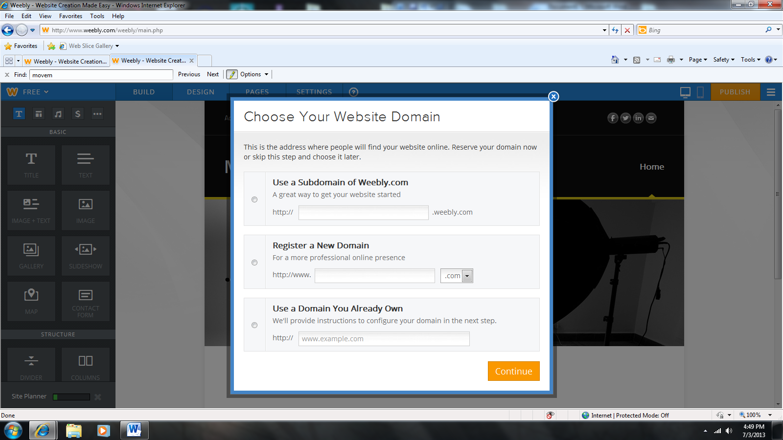

Next go through and watch the video. Watch some videos at the site planner to help you go further.
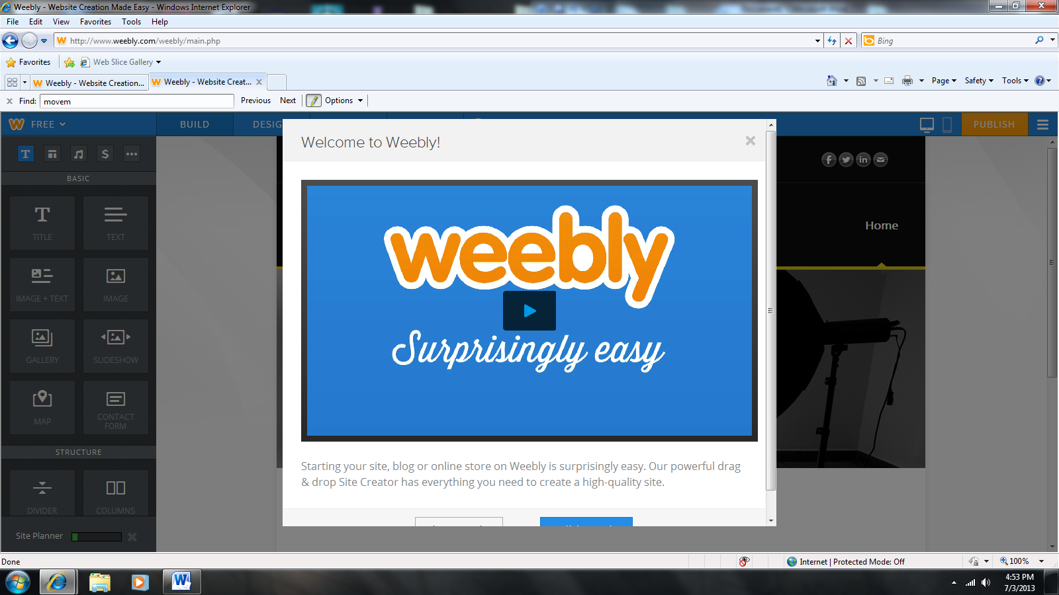
Once you are at your website experiment by adding details to your home page.
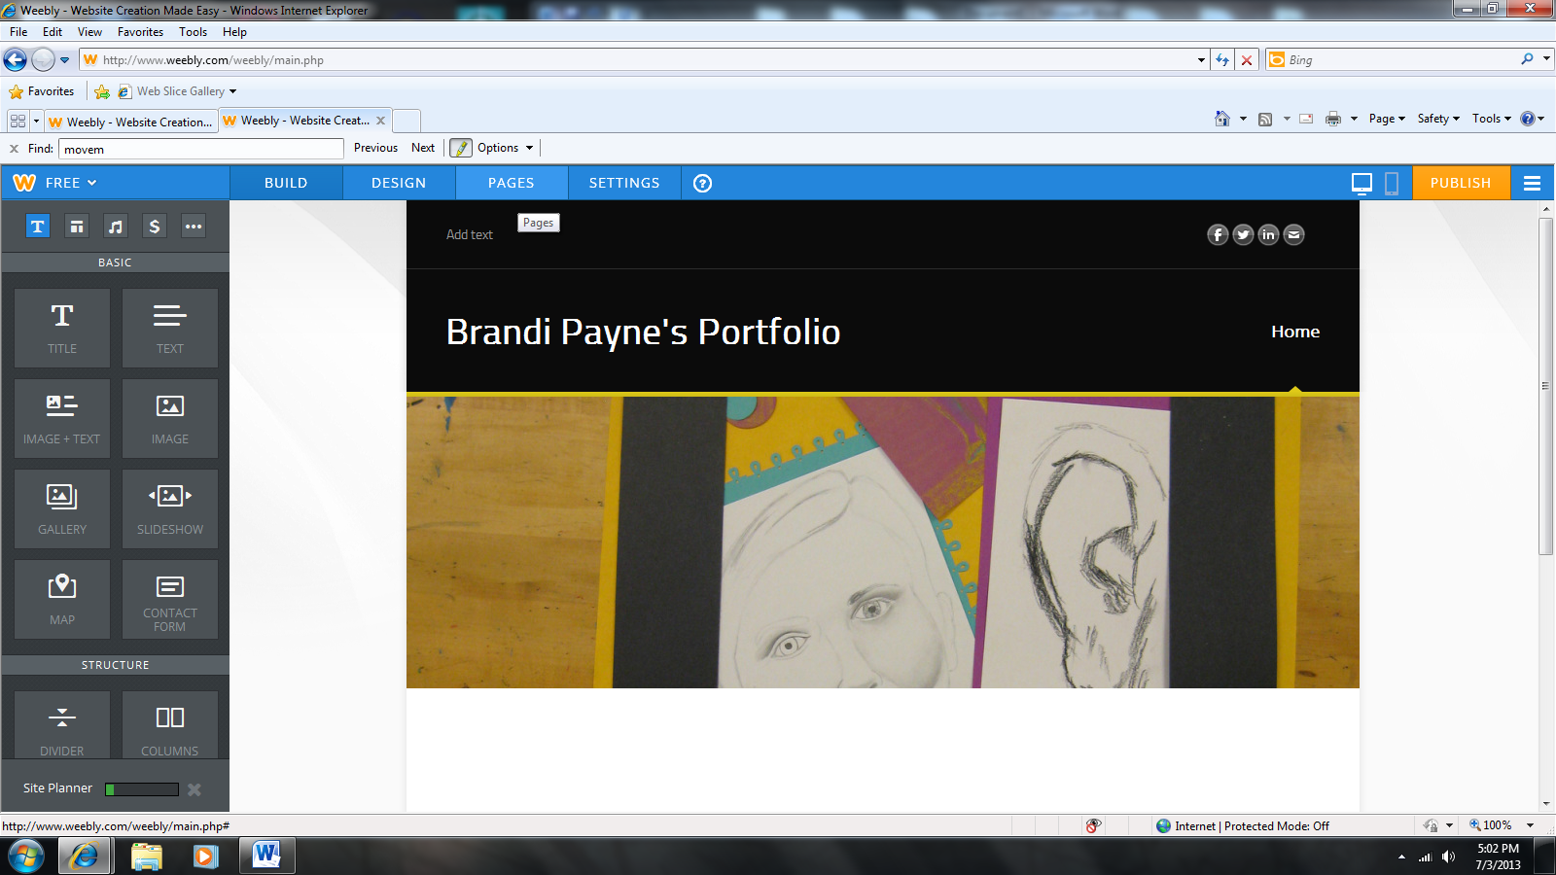
When you know how you want to set-up your portfolio you will have to add pages to make it easier to quickly find everything you need.
Click on “Add Page” at the top center of your website.
Once here type in the page name, decide on the layout and hit save and edit. You can always change details that you do not like later.
Think about having pages for the following: sketches, projects, artist statement/ thoughts
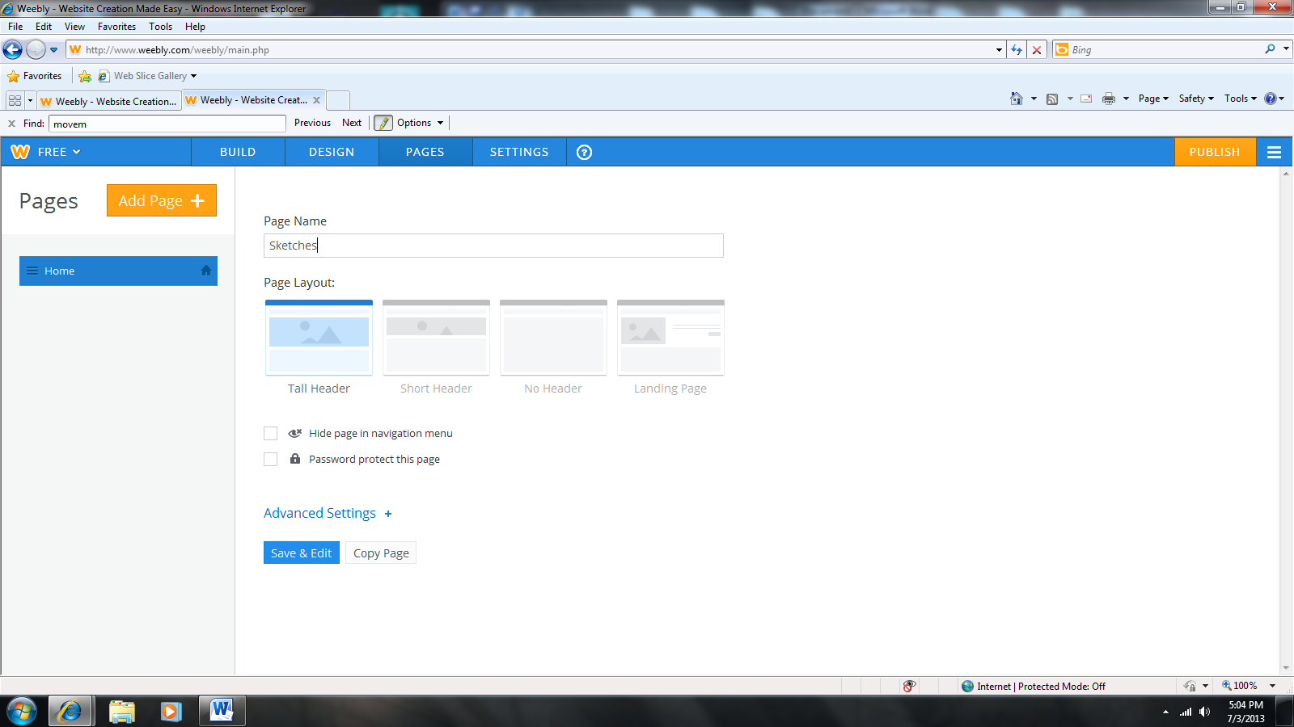
If you want to have text, images, slideshows etc. you can access all of that from the left hand side.
As you are creating your site you need to remember to hit the button in the top right hand corner “Publish”. If you do not hit publish your work will not save.
The rest is up to you to create…have fun!

